**TIC-TAC-TOE game using Mini-Max algorithm**

**Single Player:**

def printBoard(board):

print(board[1] + '|' + board[2] + '|' + board[3])

print('-+-+-')

print(board[4] + '|' + board[5] + '|' + board[6])

print('-+-+-')

print(board[7] + '|' + board[8] + '|' + board[9])

print("\n")

def spaceIsFree(position):

if board[position] == ' ':

return True

else:

return False

def insertLetter(letter, position):

if spaceIsFree(position):

board[position] = letter

printBoard(board)

if (checkDraw()):

print("Draw!")

exit()

if checkForWin():

if letter == 'X':

print("Bot wins!")

exit()

else:

print("Player wins!")

exit()

return

else:

print("Can't insert there!")

position = int(input("Please enter new position: "))

insertLetter(letter, position)

return

def checkForWin():

if (board[1] == board[2] and board[1] == board[3] and board[1] != ' '):

return True

elif (board[4] == board[5] and board[4] == board[6] and board[4] != ' '):

return True

elif (board[7] == board[8] and board[7] == board[9] and board[7] != ' '):

return True

elif (board[1] == board[4] and board[1] == board[7] and board[1] != ' '):

return True

elif (board[2] == board[5] and board[2] == board[8] and board[2] != ' '):

return True

elif (board[3] == board[6] and board[3] == board[9] and board[3] != ' '):

return True

elif (board[1] == board[5] and board[1] == board[9] and board[1] != ' '):

return True

elif (board[7] == board[5] and board[7] == board[3] and board[7] != ' '):

return True

else:

return False

def checkWhichMarkWon(mark):

if board[1] == board[2] and board[1] == board[3] and board[1] == mark:

return True

elif (board[4] == board[5] and board[4] == board[6] and board[4] == mark):

return True

elif (board[7] == board[8] and board[7] == board[9] and board[7] == mark):

return True

elif (board[1] == board[4] and board[1] == board[7] and board[1] == mark):

return True

elif (board[2] == board[5] and board[2] == board[8] and board[2] == mark):

return True

elif (board[3] == board[6] and board[3] == board[9] and board[3] == mark):

return True

elif (board[1] == board[5] and board[1] == board[9] and board[1] == mark):

return True

elif (board[7] == board[5] and board[7] == board[3] and board[7] == mark):

return True

else:

return False

def checkDraw():

for key in board.keys():

if (board[key] == ' '):

return False

return True

def playerMove():

position = int(input("Enter the position for 'O': "))

insertLetter(player, position)

return

def compMove():

bestScore = -800

bestMove = 0

for key in board.keys():

if (board[key] == ' '):

board[key] = bot

score = minimax(board, 0, False)

board[key] = ' '

if (score > bestScore):

bestScore = score

bestMove = key

insertLetter(bot, bestMove)

return

def minimax(board, depth, isMaximizing):

if (checkWhichMarkWon(bot)):

return 1

elif (checkWhichMarkWon(player)):

return -1

elif (checkDraw()):

return 0

if (isMaximizing):

bestScore = -800

for key in board.keys():

if (board[key] == ' '):

board[key] = bot

score = minimax(board, depth + 1, False)

board[key] = ' '

if (score > bestScore):

bestScore = score

return bestScore

else:

bestScore = 800

for key in board.keys():

if (board[key] == ' '):

board[key] = player

score = minimax(board, depth + 1, True)

board[key] = ' '

if (score < bestScore):

bestScore = score

return bestScore

board = {1: ' ', 2: ' ', 3: ' ',

4: ' ', 5: ' ', 6: ' ',

7: ' ', 8: ' ', 9: ' '}

printBoard(board)

print("Computer goes first! Good luck.")

print("Positions are as follow:")

print("1, 2, 3 ")

print("4, 5, 6 ")

print("7, 8, 9 ")

print("\n")

player = 'O'

bot = 'X'

global firstComputerMove

firstComputerMove = True

while not checkForWin():

compMove()

playerMove()

**Output:**

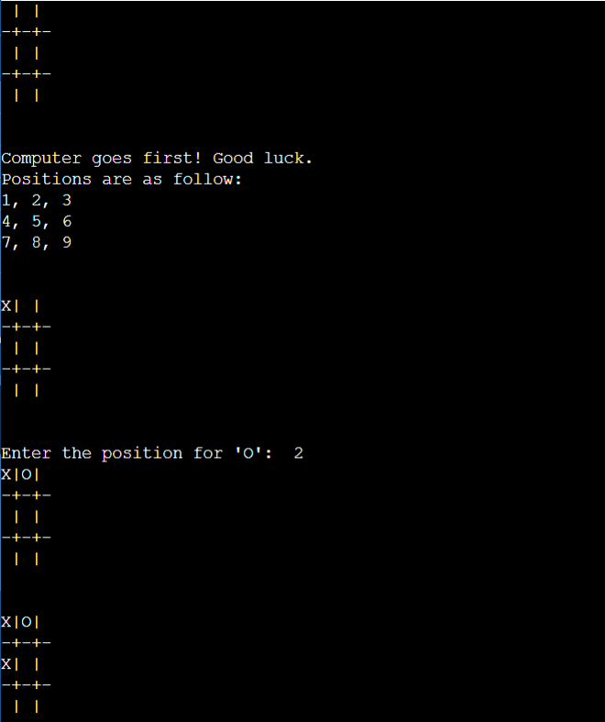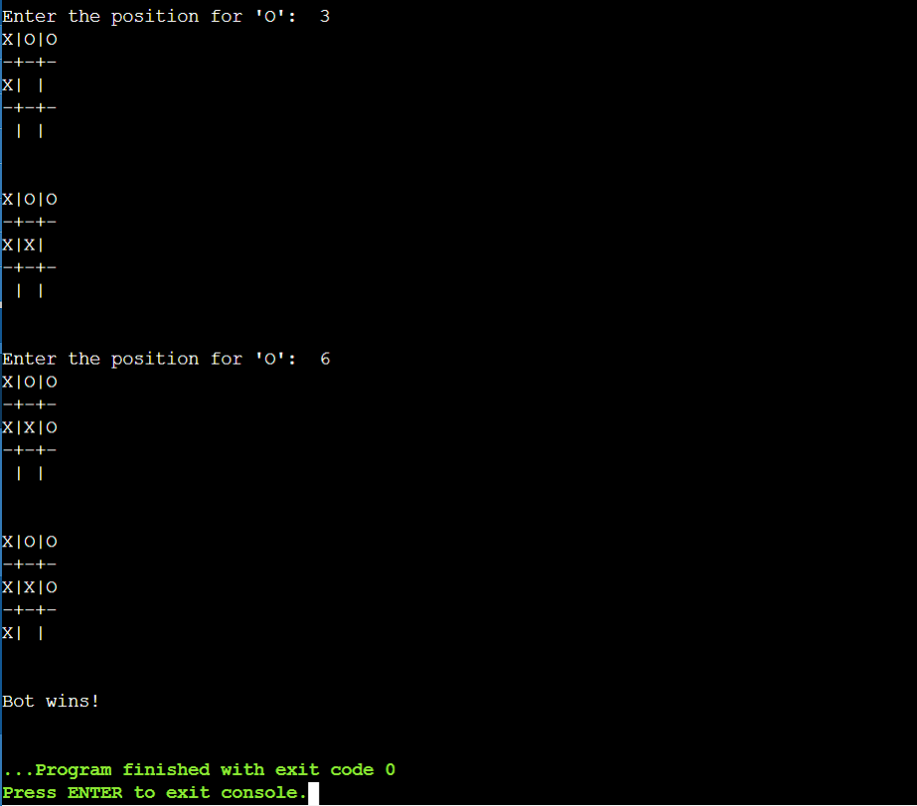

**Multi Player:**

def printBoard(board):

print(board[1] + '|' + board[2] + '|' + board[3])

print('-+-+-')

print(board[4] + '|' + board[5] + '|' + board[6])

print('-+-+-')

print(board[7] + '|' + board[8] + '|' + board[9])

print("\n")

def spaceIsFree(position):

if board[position] == ' ':

return True

else:

return False

def insertLetter(letter, position):

if spaceIsFree(position):

board[position] = letter

printBoard(board)

if (checkDraw()):

print("Draw!")

exit()

if checkForWin():

if letter == 'X':

print("x wins!")

exit()

else:

print("0 wins!")

exit()

return

else:

print("Can't insert there!")

position = int(input("Please enter new position: "))

insertLetter(letter, position)

return

def checkForWin():

if (board[1] == board[2] and board[1] == board[3] and board[1] != ' '):

return True

elif (board[4] == board[5] and board[4] == board[6] and board[4] != ' '):

return True

elif (board[7] == board[8] and board[7] == board[9] and board[7] != ' '):

return True

elif (board[1] == board[4] and board[1] == board[7] and board[1] != ' '):

return True

elif (board[2] == board[5] and board[2] == board[8] and board[2] != ' '):

return True

elif (board[3] == board[6] and board[3] == board[9] and board[3] != ' '):

return True

elif (board[1] == board[5] and board[1] == board[9] and board[1] != ' '):

return True

elif (board[7] == board[5] and board[7] == board[3] and board[7] != ' '):

return True

else:

return False

def checkDraw():

for key in board.keys():

if (board[key] == ' '):

return False

return True

def playerMove():

position = int(input("Enter the position for '0': "))

insertLetter(player, position)

return

def compMove():

position = int(input("Enter the position for 'x': "))

insertLetter(bot, position)

return

board = {1: ' ', 2: ' ', 3: ' ',

4: ' ', 5: ' ', 6: ' ',

7: ' ', 8: ' ', 9: ' '}

printBoard(board)

print("Computer goes first! Good luck.")

print("Positions are as follow:")

print("1, 2, 3 ")

print("4, 5, 6 ")

print("7, 8, 9 ")

print("\n")

player = 'O'

bot = 'X'

while not checkForWin():

compMove()

playerMove()

**Output:**

